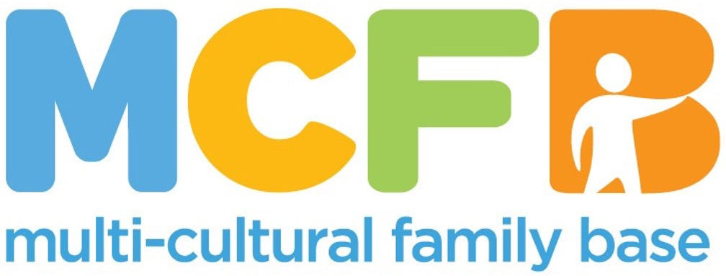

**ROLE PACK**

This is a pack that gives the role descriptions and other information about our organisation.

**ABOUT THE MULTI-CULTURAL FAMILY BASE**

**Founded with a commitment to social justice and inclusion in 1998, the Multi-Cultural Family Base (MCFB) is a leading organisation in Edinburgh dedicated to supporting diverse communities and enhancing the well-being of infants, children and families from all cultural backgrounds. MCFB provides essential community-based services, such as therapeutic group work, direct work, advocacy, and support to minoritised groups.**

**Our Values**

Multi-Cultural Family Base is an anti-racist and anti-oppressive organisation. We are passionate about promoting human rights, valuing diversity, providing equitable opportunities, and working in a way which is compassionate, responsive, respectful, and re-empowering. Multi-Cultural Family Base is committed to involving service users and stakeholders in co-production of service planning and provision.

We believe that community-based services for diverse families should be easy to access and able to respond to a wide range of needs. Our services include therapeutic groupwork and one-to-one casework. For more information go to: [www.mcfb.org.uk](http://www.mcfb.org.uk)

We are seeking two dedicated and committed people to take positions on our Board. To learn more about the roles, please look at the descriptions below.

**ABOUT THE ROLES**

**POST TITLE:** Board Chair

We’re looking for someone who shares our mission and values to lead our Board of Directors from October 2025.  As Chair, you will facilitate Board discussions, ensure effective governance of our decision-making, and provide support and strategic direction to our CEO and Business Operations manager.  You will be supported in the role by a Deputy Chair, a Treasurer, a Company Secretary and a dedicated, friendly, and collaborative group of Directors.

The role could also be performed on a Co-Chair basis.

**Core responsibilities:**

* Board meetings (held four times per year on a hybrid basis) plus AGM – you will prepare the agendas and chair the discussions.
* Board sub-committees - you will be expected to join at least one Board sub-committee (Finance, HR or Risk & Audit)
* Annual Report & Accounts – working with the CEO, Treasurer and external auditor, you will draft the Directors’ Report for the financial year and sign off the accounts once audited.
* Financial transactions / formal documentation – you may be required to authorise financial transactions and sign formal documentation on MCFB’s behalf.

We work predominantly with BME/BAME children and young people and we are a social work practice learning centre. We particularly welcome applications from people from ethnically diverse backgrounds as well as those with a social work background.

An updated PVG is required for the role. We will support the transition of the PVG to MCFB.

Please download the application form and submit to [marybainbridge@live.co.uk](mailto:marybainbridge@live.co.uk) and [carol.paton@gmail.com](mailto:carol.paton@gmail.com).

**POST TITLE:** Company Secretary

We’re looking for someone who shares our mission and values to become our Company Secretary from October 2025.  Working closely with our Chair, CEO, and Business Operations Coordinator, you will play a key role at the heart of our organisation in ensuring strong governance and compliance.  You will be supported in that role by a dedicated, friendly, and collaborative group of Directors.

The successful applicant is not required to become a Director.

**Core responsibilities:**

* Manage Board documentation and take minutes of Board meetings (held four times per year on a hybrid basis) and of the AGM.
* Maintain accurate, up to date records with Companies House and OSCR
* Ensure compliance with all relevant administrative requirements including those relating to meetings and filings

We work predominantly with BME/BAME children and young people and we are a social work practice learning centre. We particularly welcome applications from people from ethnically diverse backgrounds as well as those with a social work background.

An updated PVG is required for the role. We will support the transition of the PVG to MCFB.

Please download the application form and submit to [e.mcknight12@btinternet.com](mailto:e.mcknight12@btinternet.com) and [carol.paton@gmail.com](mailto:carol.paton@gmail.com).

